2 Megapixel IP
180° Panoramic
Dome CAMERA

FPN-B402-R
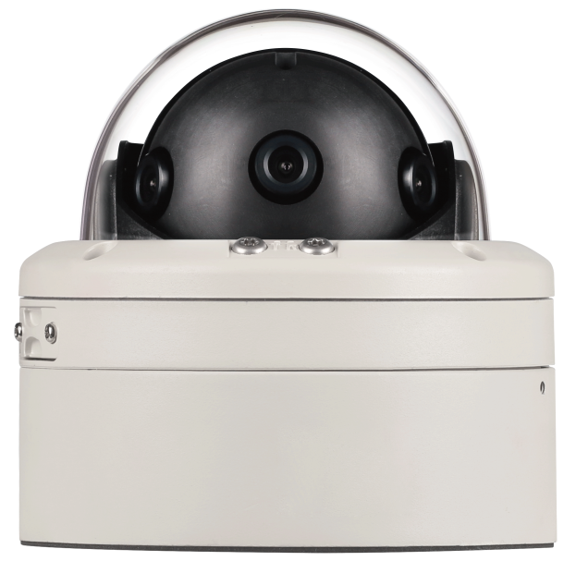






Dimension (unit : mm)

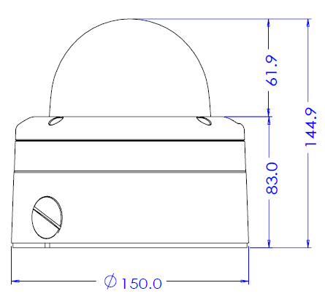
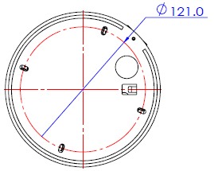

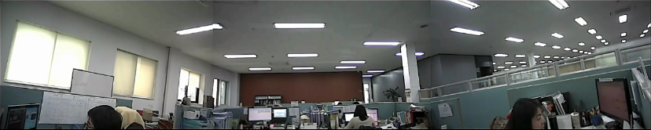

FEATURES

IP Panoramic Bullet Camera for 180° viewing angle
3 sensor (2M) and 4.3mm fixed lens allows to FOV of 180° with resolution of 6MP total.

Patented External Tilt/Rotation device Technology
External Rotation and Tilting patented wired mechanism makes the installer to adjust the camera viewing angle without opening the dome cover. With 8X zoom module will ease to focus.

Digital zoom with digital pan
Supports digital zoom with digital pan. Setting preset and preset tour is also available with this digital zoom and pan.

Real-time High Definition Bullet Camera
Using the state of art video compression engine, real time HD video streams of 1080p can be delivered for recording and monitoring.

Dual codec, Simultaneous Multi Streaming
Dual H/W codec enables to transmit max 2 independent streams with different settings for different requirements. Therefore, it is possible to combine seamless remote video monitoring using H.264 and additional MJPEG can be delivered for Mobile devices such as Smart Phone or PDA.

Local SD Card Backup
Some important sequence of still images can be stored in the SDHC memory card. This action can be configured to work with pre-post- alarm event or a given interval.

Day & Night by ICR
For increased sensitivity of image sensor efficiently, a mechanical actuator can shift infrared (IR) Cut filter to disengage from image path automatically in the low light environment.

POE
Built-in Power over Ethernet (IEEE 802.3at) makes installation easier, cheaper and more secure since Power over Ethernet can take advantage of UPS (uninterrupted power supply), which provides back-up power in case of a power failure.

Weather Proof Design
Due to IP66 environment protection as well as speed bullet camera will serve you all the time regardless of rain, snow and storm.

Specification
CAMERA
Image Device | 1/2.8” 2.4M Sony Sensor * 3ea
Resolution | 1920 (H) x 1080 (V) ~360(V)
Aspect Ratio | HD: 16:9(1x zoom) ~ 16:3 (1/3x zoom)
Focal Length | 4.3mm Board Lens * 3ea
Horizontal angle | 180 degree (each lens angle is 70 degree))
MIN. Illumination | COLOR : 0.5Lux @ F2.5, 30IRE  B/W : 0.27Lux
Day & Night | Auto / Day / Night (ICR)
Shutter Speed | Auto / Manual
Focus | Manual
AGC | Max 41dB
White Balance | Auto / Auto-Ext / Indoor / Outdoor / Manual / Preset
IR LED | N/A
TDN | Filter change mechanism
Other Functions | 3D DNR , 3 Sensor out in 1/3x Scale down,  1 Sensor out in 1x zoom

GENERAL
Camera Posture | 3 Axis (Pan/Tilt/Rotation)  External tilt and rotation adjustment
Digital In/Out | 1 Alarm Sensor In / 1 Out
Audio In / Out | 1 Audio In / 1 Out
Video Out | BNC: VBS 1.0 Vp-p
Power | DC 12V 14W, PoE 12W  POE IEEE 802.3af
Approvals | FCC, CE, IP66, ROHS
Housing | Weather proof/Vandal Proof Structure  Color: Cool Gray
Material | Aluminum Die-casting
Dimension | Net (Ø x H) Ø150 x 144.9(H) mm
Weight | 2Kg
Operating Temp. | -10°C ~ 50°C

NETWORK
OS |  | Embedded Linux
Video Compression |  | Dual Codec,H.264/MJPEG
Video Streaming |  | Multi Streaming CBR/VBR  (Controllable frame rate and Bandwidth)
Resolution |  | H.264 : 1080P/D1/CIF/QCIF  MJPEG : 1080P/D1/CIF/QCIF
Frame Rate |  | Max. 30 /25 fps  for 1080P/D1/CIF/QCIF
Audio Compression |  | Two way, G.711 PCM. μ-law 64kbps 8kHz
Local Storage |  | SDHC memory card (card is not included)
Motion detection |  | Notification: FTP, e-mail,  Alarm out, JPEG Recording on SD
Alarm |  | Pre-Post Alarm
Max No. of Clients |  | 10
Protocols  Support | IPv4 | ONVIF, TCP/IP, UDP/IP, RTP(UDP),  RTP(TCP), RTSP, NTP, HTTP,HTTPS, SSL,  DNS, DDNS, DHCP, FTP, SMTP, ICMP,  SNMPv1/v2c/v3(MIB-2)
Protocols  Support | IPv6 | TCP/IP, HTTP, HTTPS, DHCP
Protocols  Support | DDNS | Proprietary: NET4C  Public DDNS services Suport:  www.dyndns.com, www.no-ip.com
Protocols  Support | Security | HTTPS(SSL),  Digest Authentication(ID/PW)
OS Supported |  | Windows 7, Vista, XP , 2000



SECUBEST Co., Ltd
145-2, Sangdaewon-dong, Jungwon-gu, Seongnam-si,
Gyeonggi-do, 462-807, Korea.
Tel: +82-31-781 0147 Fax: +82-31-7773445
E-mail: sales@secubest.com

