2M 30x HD IP
OUTDOOR PTZ
CAMERA

PTSN-3012-W
: Wall Mount Type

PTSN-3012-C
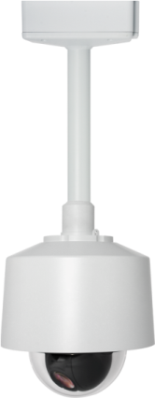
: Ceiling Mount Type
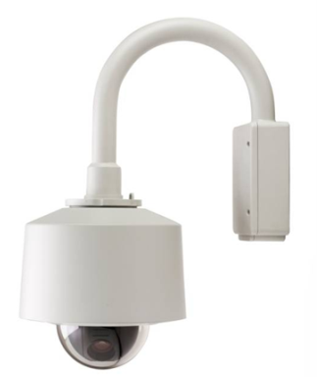




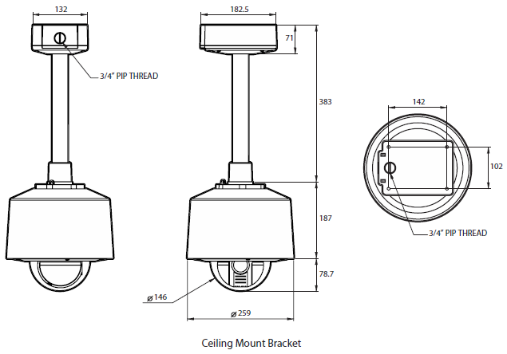
- Dimension
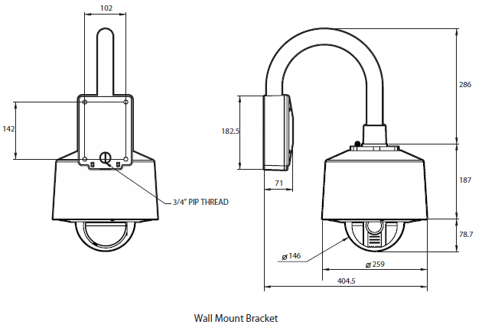

1. GENERAL FEATURES

- 360x Zoom Control (Optical 30x, Digital 12x)
- 5.7” Bubble dome enclosure
- Endless 360° Pan Rotation
- Lightning Speed (MAX.360°/sec) & Smooth Manual Speed
(MIN. 0.05°/sec)
- Ultra Low Vibration due to S-curved acceleration & deceleration.
- Day & Night (ICR)
- 1024 Preset Positions with Alphanumeric Labels
- 128 Pattern, 128 Scan and 128 Group Functions
- Power-up Action, Parking Action
- Built-in 2 Sensor Inputs and 1 Relay Output
- IP66 environment protection as well as built-in Fan & Heater
- Vandal-Proof
(Dome Cover: PC / Housing & Accessories: AL Die-cast)
- Built-in Fan & Heater

2. PTZ FEATURES

Micro-Step Technology
Due to the Micro-stepping technology, one step angle is divided by 256. Accordingly, high accuracy as well as ultra low sound noise (under 60dB) can be achieved. Micro-stepping technology enables ultra low speed down to 0.05°/s for high zoom operations.

Vector Driving
Based on the shortest time and the smallest cost concept, each Pan and Tilt motion is done with simultaneous and harmonious manner by Vector drive technology.

3. IP FEATURES

Real-time High Definition Speed Dome Camera
Using the state of art video compression engine, real time HD video streams of 1080p and 720p can be delivered for recording and monitoring.

Triple codec, Simultaneous Multi-Streaming
Triple H/W codec enables to transmit Max 3 independent streams with different settings for different requirements. Therefore, it is possible to combine seamless remote video monitoring using H.264 with simultaneous transmission of high quality MPEG-4 to Network Video Recorder. Also, additional MJPEG can be delivered for Mobile devices such as Smart Phone or PDA.

Local SD Card Backup
Some important sequence of still images can be stored in the SDHC memory card. This action can be configured to work with pre-post- alarm event or a given interval.

4. UNIQUE FEATURES

Virtual Joystick on the Image
Virtual Joystick is inspired by real 3-Axis Joystick. You can decide PT direction by right clicking the image and change the zoom in out by scrolling mouse wheel. The PT speeds are proportional to how much you deviate mouse from the center. Using this function, control of PTZ is done in instinctive manner.

Auto Map Generation
After installing PTZ, make camera to generate the Scenery Map autonomously. It will process and stitch a series of pictures to make one overall Scenery map. Using Scenery map, you can quickly switch one place to another. By drawing a bow on the map, PTZ will move to the center of the box as well as adjust zoom ratio to match the box.

Specification
CAMERA
Image Device | 1/2.8” 2.0 Mega Pixel CMOS
Effective Pixels | Approx. 2 Mega pixels
Aspect Ratio | HD: 16:9 SD: 4:3
Zoom | X30 Optical Zoom / X12 Digital Zoom
Focal Length | f = 4.6 ~ 138.0 mm, F1.6 ~ F4.7
Horizontal angle | 59.5°(W) ~2.1 °(T)
MIN. Illumination | Color: 1.7 Lux @ 50IRE, F1.6  B/W: 0.3 lux @ 50IRE, F1.6
Day & Night | Auto / Day / Night (ICR)
Focus | Auto(Near Limit setting)/  Semi Auto/ Manual
DNR | Level Adjustment(1~5)
Shutter Speed | 1/1 ~ 1/10000 sec (22Steps)
AGC | Auto / MANUAL / MAX Gain Limit
White Balance | AUTO/ATW/Manual/Indoor/Outdoor/One-Push/SodiumVaporLamp(fix/auto)
BLC | OFF/WDR/BLC
Image Stabilization | On/Off
Other Functions | POWER UP ACTION, Parking Action
PAN / TILT
Range | Pan : 360°(Endless)
Range | Tilt : 90°
Pan/Tilt Speed | Preset : 360°/ sec
Pan/Tilt Speed | Manual : 0.05°~360°/sec  (Zoom Proportional)
Pan/Tilt Speed | Scan : 1°~ 360°/ sec
Preset | 1024 Presets with Labels
Pattern | 128 Patterns
Scan | 128 Scans
Group | 128 Groups (MAX. 20 Entries for Each Group)
Privacy Zone | Spherical Privacy Zone Masking
GENERAL
Digital In/Out |  | 2 Alarm Sensor In / 1 Out
Video Out |  | BNC: VBS 1.0 Vp-p
Power |  | AC 24V Heater Off : 23W  Heater On : 55W  High-PoE IEEE 802.3at(40W)
Approvals |  | FCC, CE, IK10, ROHS, IP66
Housing |  | Vandal Proof Structure / Color: Cool Gray
Material |  | Body: Aluminum Die-casting  Clear Bubble: Polycarbonate
Dimension |  | Net (∅×H): Ø259 x 265.7 (H) mm
Weight |  | Net: 6 Kg, Package: 10.9 Kg
Operating Temp. |  | -40°C ~ 50°C / 40°F ~ 122°F

NETWORK
OS |  | Embedded Linux
DSP |  | TI DM368
Video Compression |  | Triple Codec,H.264/MPEG4/MJPEG
Video Streaming |  | Multi Streaming CBR/VBR  (Controllable frame rate and Bandwidth)
Resolution |  | H.264 : 1080p/720p/D1/CIF  MJPEG : 1080P/720p/D1/CIF/QCIF  MPEG-4 : 720p/D1/CIF
Frame Rate |  | Max. 30 fps for 1080p/720p/D1/CIF/QCIF
Audio Compression |  | Two way, G.711 PCM. μ-law 64kbps 8kHz
Local Storage |  | SDHC memory card (Card is not included)
Motion detection |  | Notification: FTP, e-mail,  Alarm out, JPEG Recording on SD
Alarm |  | Pre-Pos Alarm
Max No. of Clients |  | 10
Protocols  Support | IPv4 | ONVIF, TCP/IP, UDP/IP, RTP(UDP),  RTSP, NTP, HTTP,HTTPS, SSL,  DNS, DDNS, DHCP, FTP, SMTP, ICMP,  SNMPv1/v2c/v3(MIB-2)
Protocols  Support | IPv6 | TCP/IP, HTTP, HTTPS, DHCP
Protocols  Support | DDNS | Proprietary: NET4C  Public DDNS services Suport:  www.dyndns.com, www.no-ip.com
Protocols  Support | Security | HTTPS(SSL),  Digest Authentication(ID/PW)
OS Supported |  | Windows 7, Vista, XP

<Optional Accessories>

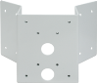
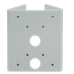
Ceiling Mount
(BC04)
Corner Mount (BCO02)
Pole Mount (BP02)
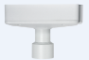



SECUBEST Co., Ltd
145-2, Sangdaewon-dong, Jungwon-gu, Seongnam-si,
Gyeonggi-do, 462-807, Korea.
Tel: +82-31-781 0147 Fax: +82-31-7773445
E-mail: sales@secubest.com

