IP KEYBOARD
CONTROLLER

SIC-3200

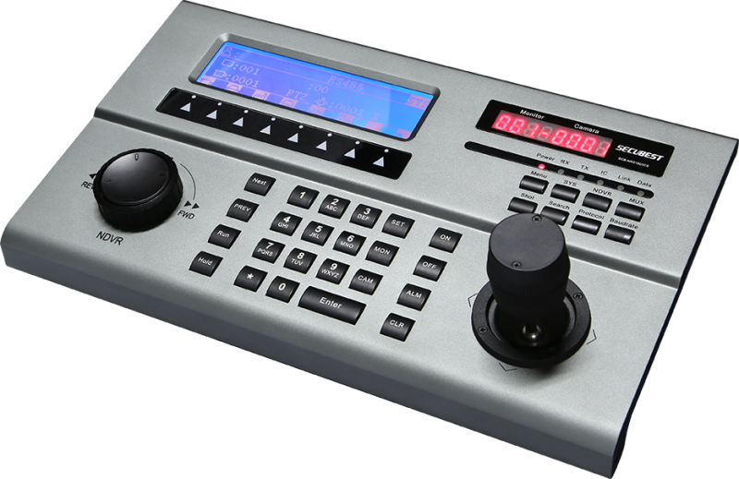

FEATURES

- 6 layer of security protection with Smartcard login
- Control Independent Self Definition Programming
- Control PTZ camera, DVR, Multiplexer & alarm with a single device
- Control up to 10000 PTZ cameras、100 (DVR) & decoder
- Easy setup of camera protocol and baud rate
- Vector-solving joystick with shuttle control for full matrix control and NVR/DVR playback control
- Dual screen display LCD showing control command, messages. Main display shows up to 4 lines of 120 characters. Auxiliary display shows up to 8 characters.
- Display on-line state of different equipment
- Segment groups of alarm and access control
- On-line display of Front end equipment
- On-line display of System function
- On-Line display of Preset position
- On-line display of Alarms
- All aluminum chassis ensure durable usage
- Sleek design ensure it bland into modern control room design
- Back Lit LCD display ensure clear display of commands

DESCRIPTION

SIC-3200 is a vector-solving joystick with shuttle control dual screen display intelligent keyboard. It can communicate via IP Ethernet or Serial Data connection. In a Virtual Matrix environment, the keyboard is able to control the PTZ, and switching of input to any output with appropriate Video Management Software. It is able to operate directly with Pelco、AB、AD、MAX1000 video matrix switcher. It has innovative technology, stable performance, simple operation, and have a backup, set other useful features. This is a digital security monitoring system rational choice.

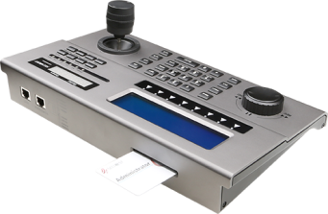

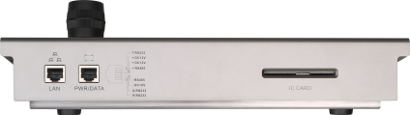

SPECIFICATIONS

TECHNICAL
Communication | RS485、RS232、TCP/IP
Interface | RJ45
Display | 240Å~64、LED backlit、12 character display
Language | English, Chinese
Joystick | Vector Solving 3 axis
Button | Light touch
Temperature | -10℃～50℃
Humility | ＜95%RH (non-condense)
Weight | 2.5Kg
Dimension | 320mm×185mm×54mm

PROTOCOL
Camera Control | VC、Pelco D/P、Panasonic、Samsung、Secubest
IP Camera | Secubest, Axis
DVR/MUX | VC、DSCP、HIK、TUMIN、MITSU, DH, HIK-NET
Video Matrix | VC、AD、AB、Pelco, MAX1000
Power | 12V/DC, 110/230Vac adaptor included

